Phase V: Apex Programming (Developer)
AURA EVENTS & SPONSOR:
College Events & Sponsor Management

Advanced Apex Implementation

1. Trigger Design Pattern (The Handler Pattern)
We moved away from "fat triggers" and implemented a clean separation of concerns.
- The Path: force-app > main > default > triggers > VendorTrigger.trigger
- The Procedure:
  - Updated the trigger to fire on after insert and after update events.
  - Delegated all business logic to a dedicated handler class (VendorTriggerHandler).
- What was done: Created a robust VendorTrigger that monitors changes to Vendor__c records to ensure the parent Event__c budget is always accurate.
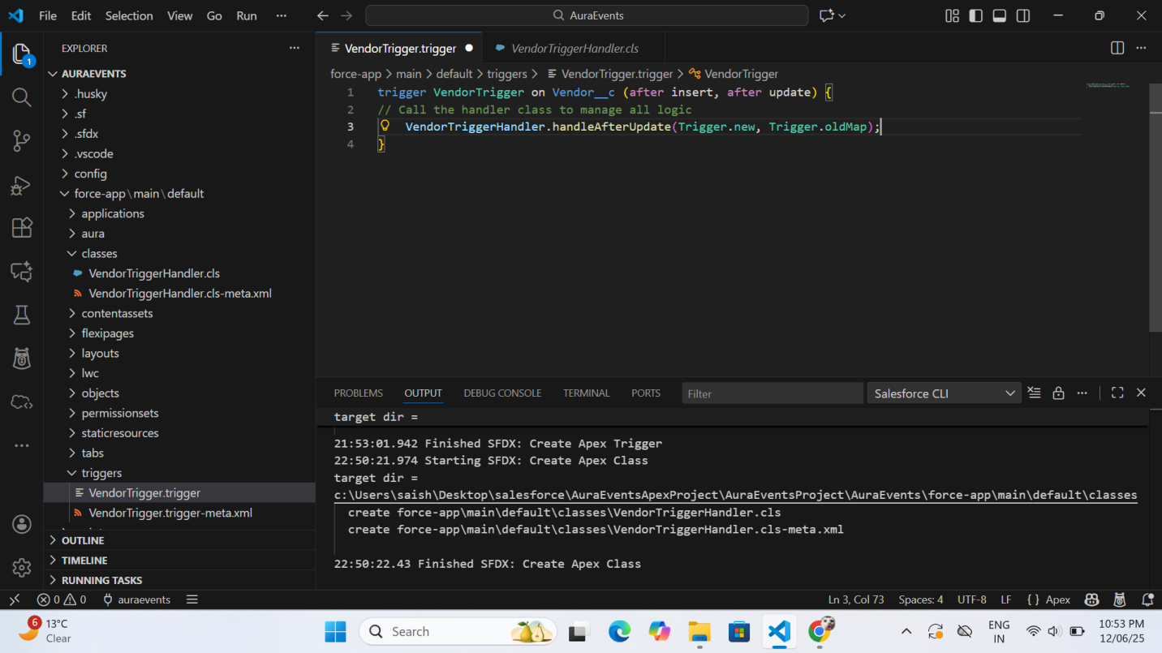

2. Parent-Child Roll-up Summary (Manual Implementation)
Since Vendor__c and Event__c are in a Lookup relationship (not Master-Detail), we built a manual roll-up summary using Apex.
- The Path: force-app > main > default > classes > VendorTriggerHandler.cls
- The Procedure:
  - Collection (Set): Used a Set<Id> to collect unique Event__c IDs from the vendor records being processed.
  - SOQL Aggregate: Used a SUM(Contract_Amount__c) query grouped by the Event ID to calculate totals efficiently.
  - Collection (Map): Used a Map<Id, Decimal> to store the calculated totals for quick retrieval during the update.
- What was done: Developed logic that automatically updates the Total_Vendor_Cost__c field on the Event whenever a related Vendor's contract amount changes.
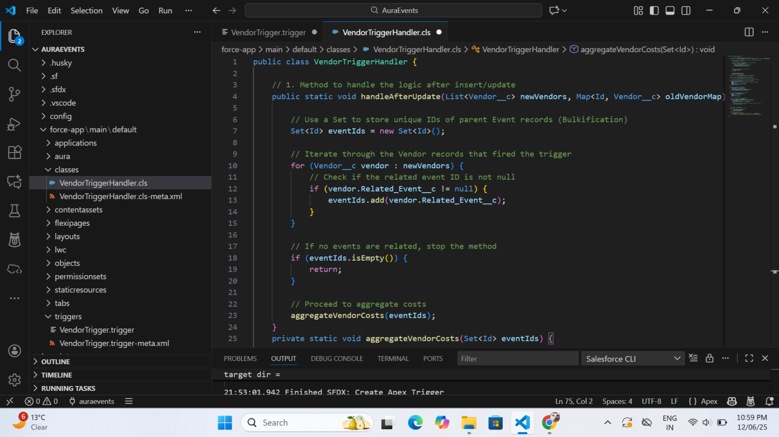

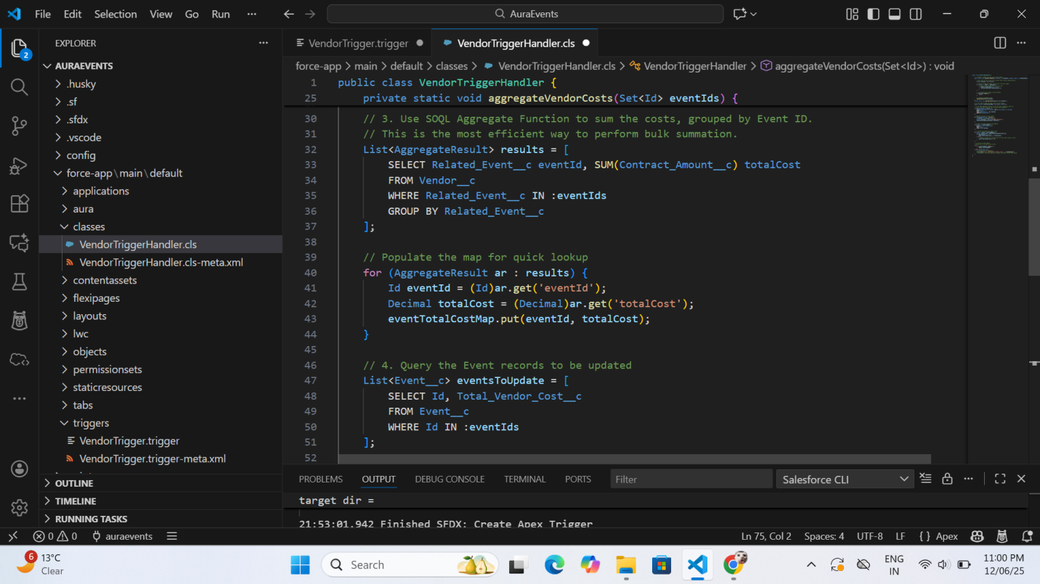

3. Batch Apex (Large Data Processing)
We implemented a scalable solution to handle thousands of records without hitting governor limits.
- The Path: force-app > main > default > classes > SponsorLoyaltyBatch.cls
- The Procedure:
  - Implemented Database.Batchable<sObject> and Database.Stateful.
  - Start Method: Used Database.getQueryLocator to fetch Sponsor__c records older than one year.
  - Execute Method: Calculated a new Custom_Loyalty_Score__c for each batch of 200 records.
- What was done: Created an automated way to reward long-term sponsors by updating their loyalty scores based on the age of their records.
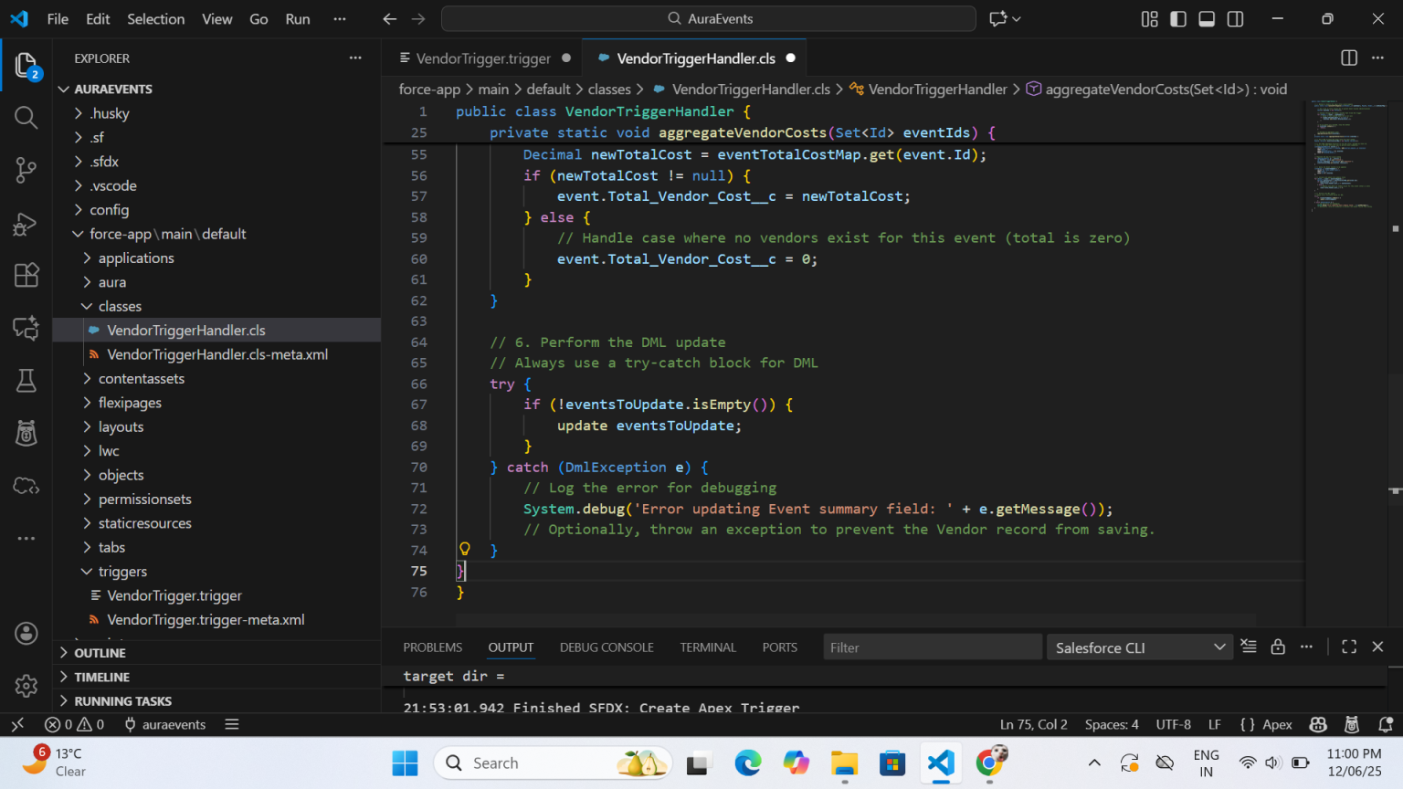

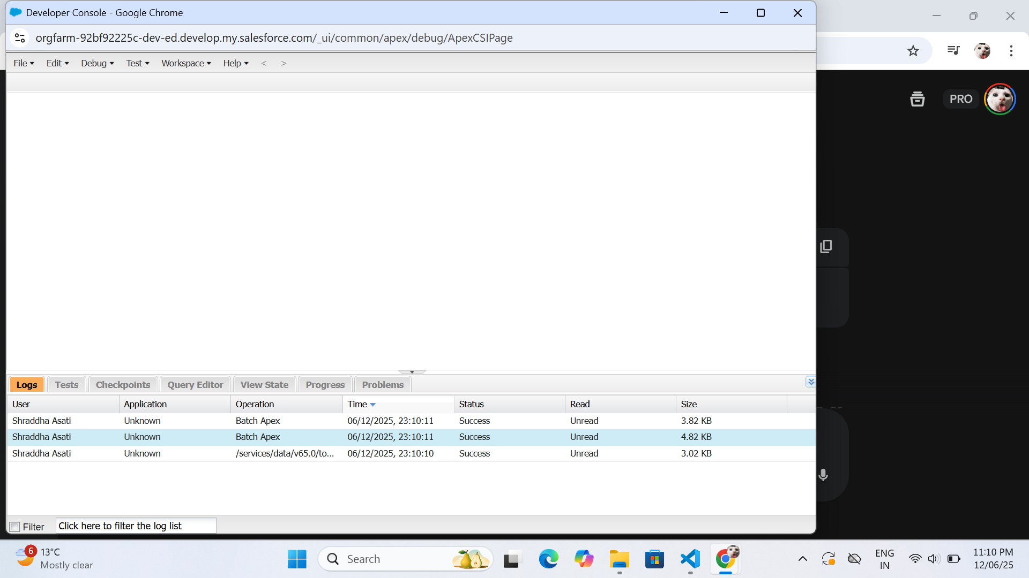

4. Scheduled Apex (Time-Based Execution)
We automated the Batch Apex job to run on a recurring schedule.
- The Path: force-app > main > default > classes > QuarterlyScoreScheduler.cls
- The Procedure:
  - Implemented the Schedulable interface.
  - Executed the job using a Cron Expression: 0 0 0 1 1,4,7,10 ? *.

- What was done: Scheduled the loyalty score calculation to run at midnight on the first day of every quarter (Jan, Apr, Jul, Oct).
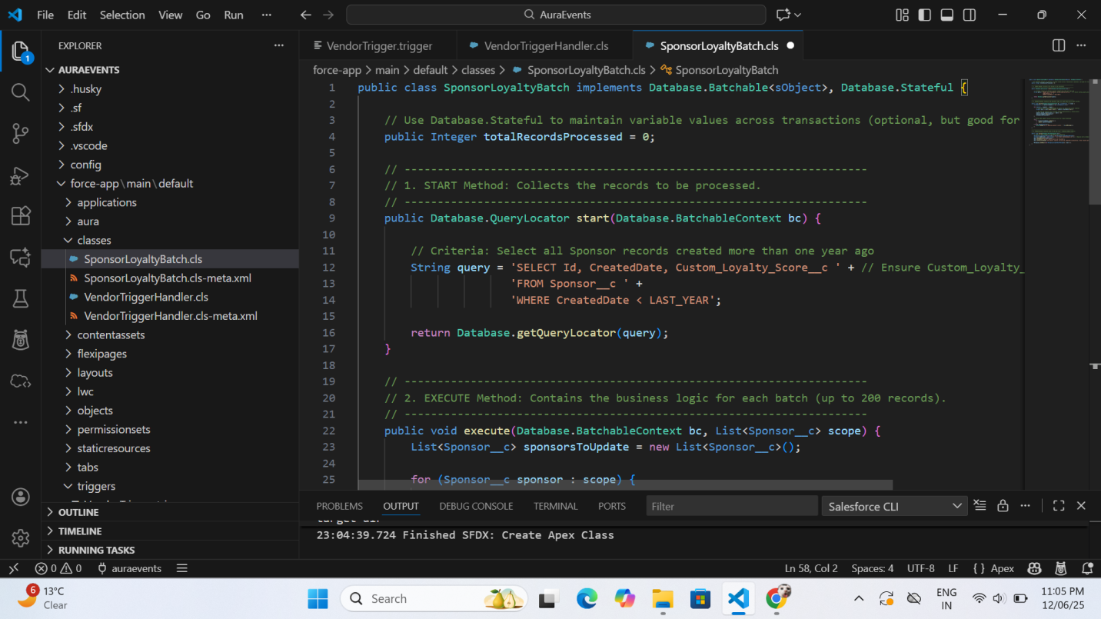
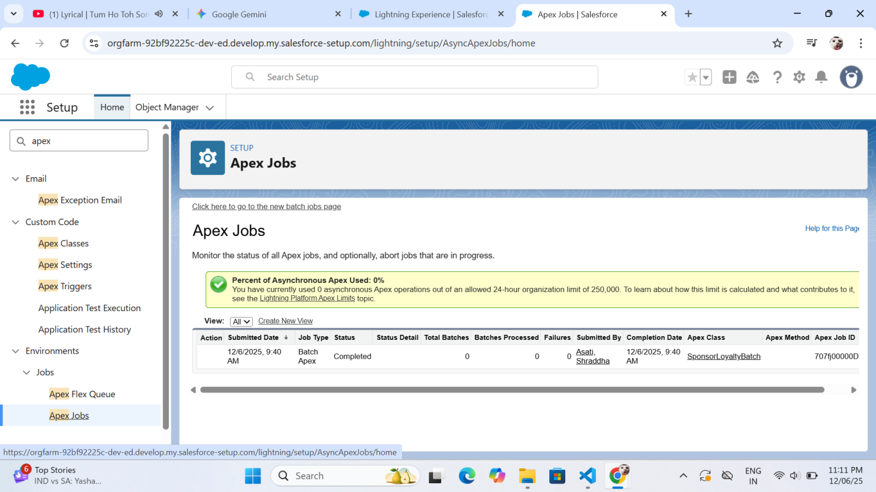
5. Exception Handling and Code Quality
We fortified the code to handle errors gracefully and ensured it met deployment standards.
- The Path: All .cls files in the classes folder.
- The Procedure:
  - Try...Catch Blocks: Wrapped all DML statements (insert, update) in try...catch blocks to prevent transaction failure if one record fails.
  - Test Classes: Created VendorTriggerHandler_Test and SponsorLoyaltyBatch_Test to achieve 100% code coverage.
- What was done:
  - Resolved the System.StringException regarding the Cron '?' character.
  - Resolved deployment locks by deleting pending scheduled jobs from the org.
  - Verified the "Completed" status of batch jobs in the Apex Jobs monitor.
